Preamble

The National Board of Accreditation is an autonomous body in India responsible for assessing and accrediting technical education programs to ensure quality and outcome-based education. As per NBA guidelines, engineering programs must adopt an Outcome-Based Education (OBE) framework, where the focus is on measuring the attainment of Course Outcomes (COs), Program Outcomes (POs), and Program Specific Outcomes (PSOs). CO–PO–PSO attainment plays a crucial role in evaluating how effectively the curriculum, teaching–learning processes, and assessments contribute to achieving the intended learning outcomes. It provides a quantitative measure of student performance and helps in identifying gaps between expected and actual attainment levels. This systematic evaluation not only supports continuous improvement in teaching and curriculum design but also ensures that graduates are equipped with the necessary knowledge, skills, and competencies required by industry and society.

Let us discuss how CO–PO–PSO attainment is calculated in the Department of Artificial Intelligence and Machine Learning (AIML). The attainment process involves mapping Course Outcomes (COs) with Program Outcomes (POs) and Program Specific Outcomes (PSOs), followed by evaluating student performance using direct and indirect assessment methods. Based on the mark’s distribution and mapping strength, attainment levels are computed systematically to measure the extent to which the defined outcomes are achieved.

Origin of NBA
- Established in 1994 under the All-India Council for Technical Education (AICTE)
- Became an independent autonomous body in 2010
- India became a permanent member of the Washington Accord in 2014
- This gives global recognition to NBA-accredited engineering programs.

Course Outcomes (CO)
- COs are specific, measurable statements of what a student should achieve at the end of a course.
- Defined by course instructors
- COs are course-level outcomes

Program Outcomes (PO)
- POs are broad abilities students should acquire by the end of the entire program (B.E.)
- Defined by NBA (PO1 to PO12-Till July 2025) (PO1 to PO11-From August 2025)
- POs are program-level outcomes

Program Specific Outcomes (PSO)
- PSOs are program-specific skills defined by the department
- Focus on specialization (e.g., AIML)
- PSOs are specialization-level outcomes

Relationship Between CO, PO, PSO
- COs contribute to POs and PSOs
- PO attainment is calculated based on CO attainment
- PSOs focus on domain-specific expertise
By focusing on CO, PO, and PSO attainment, institutions can continuously improve and produce industry-ready graduates.

Complete Flow Attainment Calculation:
Student Marks
↓
CO Attainment
↓
CO–PO Mapping
↓
Course-wise PO Attainment
↓
Program-level PO Attainment
↓
Compare with Target
↓
Action Taken Report (ATR)

What is CO Attainment?

CO Attainment is the quantitative measurement of how effectively students achieve the learning outcomes of a course, based on their performance in assessments.
Are students actually learning what we intended them to learn?
Example:CO1 target = 60%, for a class of 70 students
- Total students = 70
- CO1 target = 60%
- Target marks (threshold) = 60 out of 100
- At least 60% of students must score ≥ 60 marks in CO1
- 60% of 70 is 42, means Minimum 42 students must score ≥ 60 marks

Table 1: Scenario 1 for CO1 Attainment
Category | Number of Students | CO1 Attainment | Attainment Status
≥ 60 marks | 45 students | (45/70) ×100=64.28% | Achieved
< 60 marks | 25 students | (25/70) ×100=35.72%
Total | 70

Table 2: Scenario 2 for CO1 Attainment
Category | Number of Students | CO1 Attainment | Attainment Status
≥ 60 marks | 38 students | (38/70) ×100=54.28% | Not Achieved
< 60 marks | 25 students | (25/70) ×100=35.72%
Total | 70

Table 3: Attainment Level Conversion
Target | Attainment | Level
60% | ≥ 80% | Level 3
60% | 60–79% | Level 2
60% | < 60% | Level 1

Table 4: CO1 Attainment Level
Category | Number of Students | CO Attainment | Level
≥ 60 marks | 52 students | (62/70)×100=88.57% | 3
≥ 60 marks | 45 students | (45/70)×100=64.28% | 2
< 60 marks | 25 students | (25/70)×100=35.72% | 1
Total | 70

For CO1, the target was set at 60%. In Table 1, Out of 70 students, 45 students scored above the threshold marks, resulting in 64.28% attainment. Means 64.28% of students have scored more than 60% of marks. Hence, CO1 is attained at Level 2 as shown in Table 4.

What is PO Attainment?

PO Attainment (Program Outcome Attainment) is a core concept in Outcome-Based Education used by the National Board of Accreditation to evaluate whether students of a program (e.g., B.E) are achieving the Program Outcomes (POs) by the time they graduate. PO attainment is the quantitative measure of how well students achieve program outcomes, calculated using CO attainment, CO–PO mapping, and indirect assessment methods. It is a Measurement of how well students achieve the Program Outcomes of a degree program.
Are graduates acquiring the skills, knowledge, and abilities expected from the program?
The extent to which students have achieved the Program Outcomes (POs) by the time they graduate.
PO attainment = Aggregated performance of students across all courses mapped to that PO
Table 5 : List of Program Outcomes
PO# | PO1 to PO 12 (Till August 2025) | PO1 to PO 11(From 2024-25-Even Sem)
PO1 | Engineering Knowledge | Engineering Knowledge
PO2 | Problem Analysis | Problem Analysis
PO3 | Design/Development of Solutions | Design/Development of Solutions
PO4 | Conduct Investigations of Complex Problems | Conduct Investigations of Complex Problems
PO5 | Modern Tool Usage | Engineering Tool Usage
PO6 | The Engineer and Society | The Engineer and The World
PO7 | Environment and Sustainability | Ethics
PO8 | Ethics | Individual and Collaborative Team work
PO9 | Individual and Team Work | Communication
PO10 | Communication | Project Management and Finance
PO11 | Project Management and Finance | Life-Long Learning
PO12 | Life-long Learning

How PO Attainment is Calculated
PO attainment is not measured directly.
It is derived from:
✔️ CO Attainment (Direct Method)
- COs are mapped to POs
- CO attainment contributes to PO attainment
✔️ Indirect Method
- Surveys (students, alumni, employers)

What is PO Target?
PO Target is the minimum expected level of attainment that a program aims to achieve for each Program Outcome (PO).
PO attainment is calculated using two methods:
A. Direct Attainment (70–80%) Comes from CO attainment ,based on:
- CIE
- SEE
- CES
B. Indirect Attainment (20–30%) based on surveys:
- Exit survey
- Alumni survey
- Employer survey
How to Set PO Targets, How to Decide Target?
1. Past Data
- Previous PO attainment = 55%, 58%
Set target = 60%
2. Benchmark
- Average college → 60%
- Top institute → 65–75%
3. Continuous Improvement
Every cycle:
- Increase target gradually
PO target is NOT used in calculation Used only for:
- Comparison
- Decision making

How to Calculate PO Attainment?
Step 1: Calculate CO Attainment
Step 2: CO–PO Mapping
Step 3: Calculate PO Contribution from One Course
$$\text{PO Attainment}=\frac{∑(\text{CO Attainment}×\text{CO–PO Mapping Level})}{∑(\text{Mapping Levels})}$$Step 4: Combine All Courses if multiple courses contribute:
Final PO1 = (PO1_course1+PO1_course2+...) / (No. of courses)
Step 5: Add Indirect Attainment
Final Formula:
$$PO=0.8×Direct+0.2×Indirect$$Step 6: Final Comparison with Target

PO | Attainment | Target | Status
PO1 | 66% | 60% | ✅ Achieved
PO2 | 58% | 60% | ❌ Not Achieved

Step 7: Gap Analysis After Calculation?
If Achieved:
- Maintain teaching quality
- Slightly increase target
If Not Achieved:
Take actions:
- Improve weak COs
- Change teaching methods
- Add assignments/labs

Attainment calculation explained with an example:

For the computation of CO–PO–PSO attainment, a comprehensive Excel-based framework has been developed consisting of multiple interconnected worksheets, each dedicated to a specific component of the attainment process. The first worksheet, namely the Theory Sheet, captures Continuous Internal Assessment (CIA-1, CIA-2, CIA-3) marks on a question-wise basis along with corresponding CO mappings, Assignment/Activity Tests (AAT), quiz scores, and Semester End Examination (SEE) marks, which are collectively used to compute theory CO attainment. The second worksheet, the Lab Sheet, records lab test and continuous evaluation marks mapped to respective COs to determine laboratory CO attainment. The third worksheet focuses on Course Exit Survey (CES), where student feedback is collected and analysed to compute indirect attainment levels. The fourth worksheet, CO–PO–PSO Mapping Sheet, defines the correlation between COs and Program Outcomes (PO1 to PO11) as well as Program Specific Outcomes (PSO1, PSO2, PSO3) using predefined mapping levels. Finally, the CO–PO–PSO Assessment Sheet integrates all computed values to determine overall CO attainment and subsequently derive PO and PSO attainment levels. All worksheets are interconnected through well-defined Excel formulas, ensuring automation, consistency, and accuracy in the attainment calculation process.

Course Title :Data Structures with Applications
Type of Course : IPCC

Prerequisite:
- Theory CIA (Continuous Internal Assessment) Marks Question and CO Wise.
- Lab Test and CIE (Continuous Internal Evaluation) Marks.
- SEE (Semester End Examination) Marks for 100 and Grade for Theory/Lab.
- CES (Course Exit Survey) Values Entered by Students (Include Only the Rows if Students have entered the Data).
- CIE and SEE Question Paper.
- CO (Course Outcomes) and PO (Program Outcomes) Mapping Strengths.

STEP 1: PART OF THEORY SHEET
Using this sheet, we will calculate Theory CO Attainment
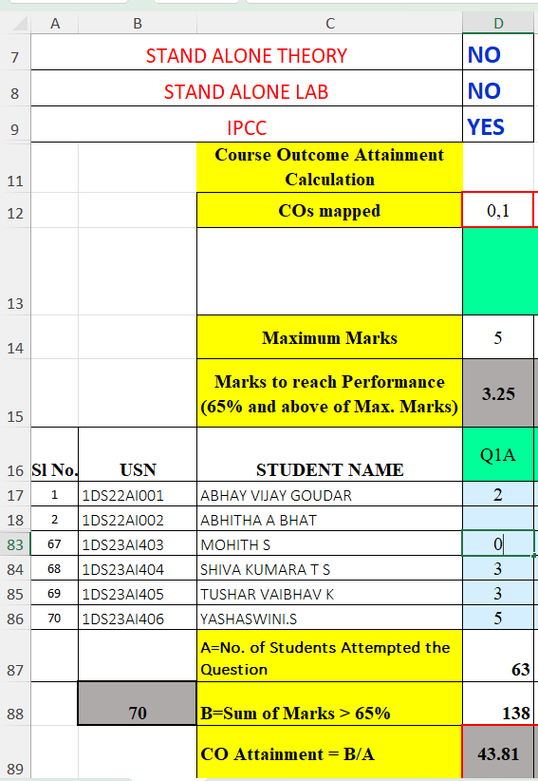
- Fill Header fields as per course used for attainment.
- Type YES or NO Based on course type
STAND ALONE THEORY | NO
STAND ALONE LAB | NO
IPCC | YES

- Fill row 12- with CO number for each question followed by default 0,
Example: D12 = 0,1
- Fill row 14 with Max marks for each question
Example: D14 = 5
- Fill row 15 to calculate Marks to reach Performance.
Example if target set is 65% then use equation PRODUCT (Max Marks,0.65)
Example: D15 = 5*0.65 = 3.25
- Enter Student USN and NAME
Example: B17 , C17 to B86 , C86
- Fill marks scored, question wise from row 17 till last student, column D to CU, also don’t delete extra columns.
Example:
D17 = 2 ( STUDENT HAS SCORED 2 OUT OF 5)
D18 = ( STUDENT HAS NOT ATTENDED THE QUESTION SO LEAVE BLANK)
D83 = 0 ( STUDENT SCORED 0 OUT OF 5)
. . .
D86 = 5 ( STUDENT HAS SCORED 5 OUT OF 5)

- Fill column CV and CW with AAT and Quiz marks for 10 each.
- Fill column DC and DD with SEE marks for 100 and Grade respectively.
- Column CX to DB will be calculated automatically to display CIA1, CIA2, CIA3, Final CIA and SEE for 50 marks.
- After entering the marks manually as specified in previous steps , below values will be calculated automatically for which the equations are given below .

A=No. of Students Attempted the Question
Example:
D87 = 63 (Out 0f 70 Students 63 students have attempted the question,
It excludes Absent, Not Eligible and not Attempted students)

D87 | A=No. of Students Attempted the Question | COUNTIFS (D17:D86,"<>AB”,  D17:D86,"<>NA”,  D17:D86,"<>")

B = Sum of Marks >= 65% (This represents minimum acceptable performance
for CO achievement.)
Example: D88 = 138
- If 40 out of 70 students scored ≥ 65%, sum marks of those 40 students only.
- Consider only students who scored ≥ 65% in that question.
- Students scoring below 65% are ignored for attainment.

D88 | B=Sum of Marks >= 65% | SUMIF (D17:D86,">="&D15,  D17:D86)

CO attainment calculation:
This expression is used to measure how well students have achieved a particular CO, considering only students who met the attainment threshold (≥65%)
Given Expression
D89= Sum of marks of students scoring ≥ 65% / Number of students who attempted the Question
------------------------------------------------------------------------------------------------------------------- * 100
Maximum marks for the Question

D89=((D88/D87)/D14)*100,0)

D89=((138/63)/5)*100,0)
D89 = 43.81
Number of students attempted the question is the denominator:
Some institutions use the number of students who scored ≥ 65% instead, Our formula uses students attempted which slightly lowers attainment and is stricter.
Divide by Maximum marks of each question:
- Makes attainment comparable across questions with different maximum marks.
- The final result is a normalized CO attainment value (between 0 and 1).
- It indicates how strongly the class achieved the CO considering:
D89 | CO Attainment | IF(D87<>0, ((D88/D87)/D14) *100,0) +

STEP 2: LAB SHEET
Using this sheet, we will calculate Lab CO Attainment and Lab PO Attainment

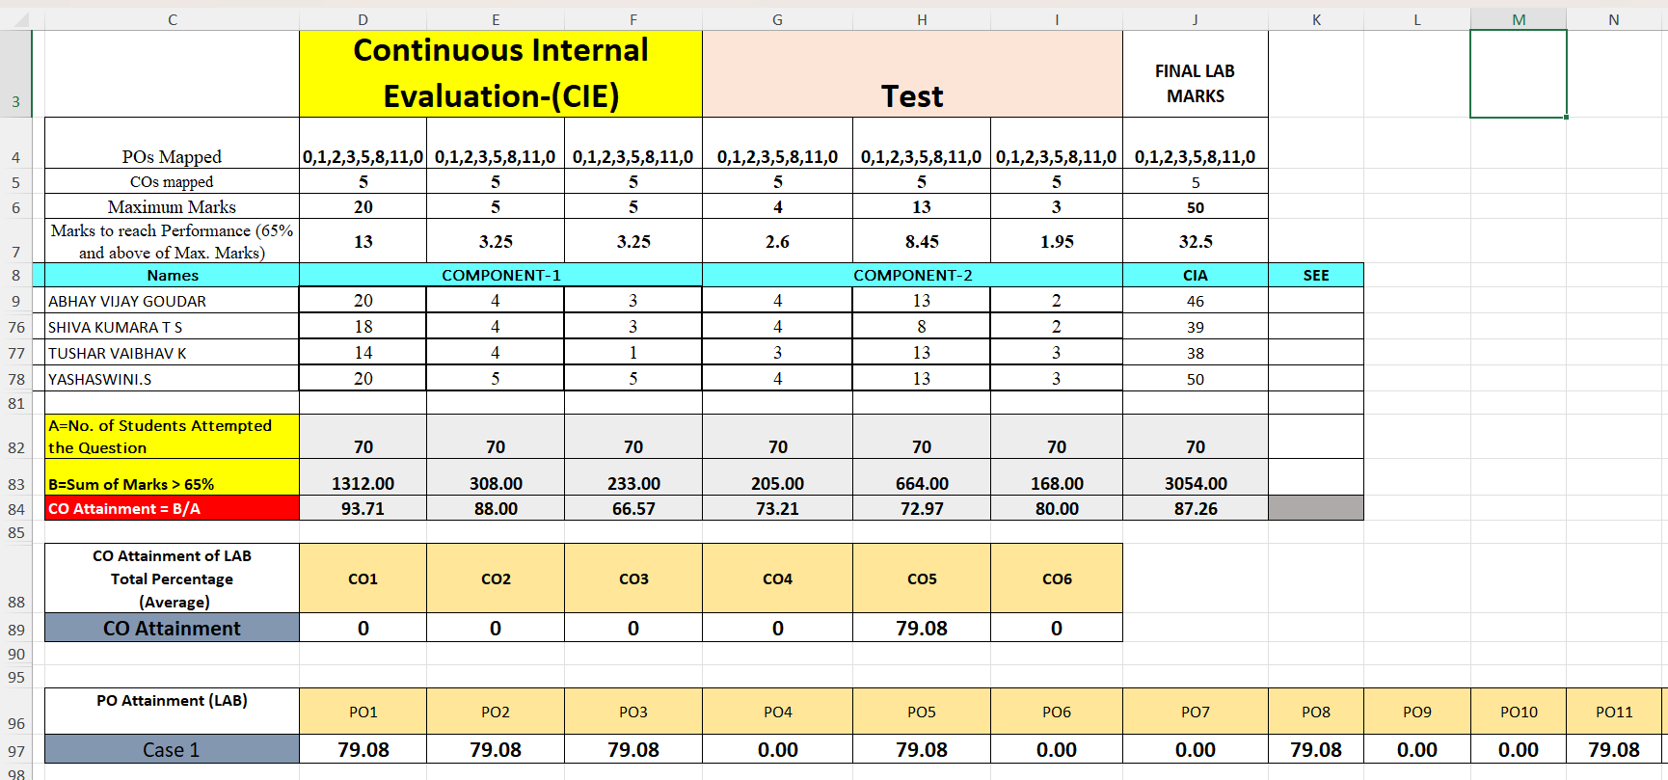
- Fill row 4 with PO number begin and end with 0
- Fill row 5 with CO number
- Fill row 6, column D to column I with max marks for CIE and LAB TEST as per lab rubrics.
- Fill column K with SEE marks, if applicable based on course type(only for Stand alone Lab)
- Same as Theory sheet calculate CO Attainment for each rubric for Lab sheet also.
A=No. of Students Attempted the Question | 70
B=Sum of Marks > 65% | 1312.00
CO Attainment | 93.71

- Co wise average for lab Total percentage is calculated using the below formulae.
Note: In below equation use D5: I5 or L5 based on last column of Lab marks. Also, the course considered will map only CO5 for Lab Course. So, calculate CO5 only.

CO1 Attainment = IF(COUNTIFS($D$5:$L$5,"=1",$D84:$L84,"<>0")=0,0,SUMIF($D$5:$L$5,"=1",$D84:$L84)/COUNTIFS($D$5:$L$5,"=1",$D84:$L84,"<>0"))
CO2 Attainment =
IF(COUNTIFS($D$5:$L$5,"=2",$D84:$L84,"<>0")=0,0,SUMIF($D$5:$L$5,"=2",$D84:$L84)/COUNTIFS($D$5:$L$5,"=2",$D84:$L84,"<>0"))
CO3 Attainment =
=IF(COUNTIFS($D$5:$L$5,"=3",$D84:$L84,"<>0")=0,0,SUMIF($D$5:$L$5,"=3",$D84:$L84)/COUNTIFS($D$5:$L$5,"=3",$D84:$L84,"<>0"))
CO4 Attainment =
=IF(COUNTIFS($D$5:$I$5,"=4",$D84:$I84,"<>0")=0,0,SUMIF($D$5:$I$5,"=4",$D84:$I84)/COUNTIFS($D$5:$I$5,"=4",$D84:$I84,"<>0"))
CO5 Attainment =
=IF(COUNTIFS($D$5:$I$5,"=5",$D84:$I84,"<>0")=0,0,SUMIF($D$5:$I$5,"=5",$D84:$I84)/COUNTIFS($D$5:$I$5,"=5",$D84:$I84,"<>0"))
CO PO Mapping of Lab:

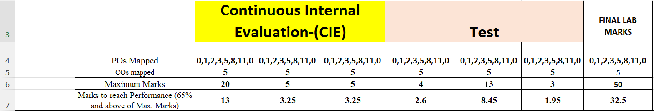

CO Attainment of Lab:
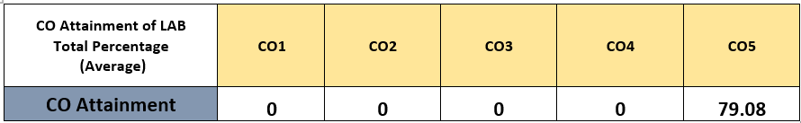

PO Attainment of Lab:

PO attainment is calculated by finding the average of all COs which are mapped with the PO.
Here PO1 is mapped with CO5.
Therefore, PO1 attainment = ((Attainment of CO1)/ (1)) = 79.08/1 = 79.08
If PO1 is mapped with more than one CO like, CO1, CO2 and CO4,
Then PO1 Attainment = (CO1 Attainment + CO2 Attainment + CO4 Attainment) / 3)

STEP 3: CES SHEET
In the Outcome-Based Education framework prescribed by the National Board of Accreditation, Course Exit Survey is used as an indirect assessment tool to evaluate the attainment of Course Outcomes (COs). The responses collected from students are based on a 5-point Likert scale ranging from Strongly Agree (5) to Strongly Disagree (1). To analyse these responses quantitatively, a weighted average method is used, where each response is multiplied by its respective weight and divided by the total number of responses. This ensures that higher ratings contribute more significantly to the final score, reflecting the overall student perception accurately. Since NBA recommends expressing attainment levels on a 3-point scale, the obtained weighted average (on a 1–5 scale) is further normalized to a 1–3 scale. This normalized value represents the indirect CO attainment, which is then combined with direct assessment (typically in an 90:10 ratio) to compute the final CO attainment. This method ensures transparency, uniformity, and alignment with NBA’s
outcome-based assessment practices.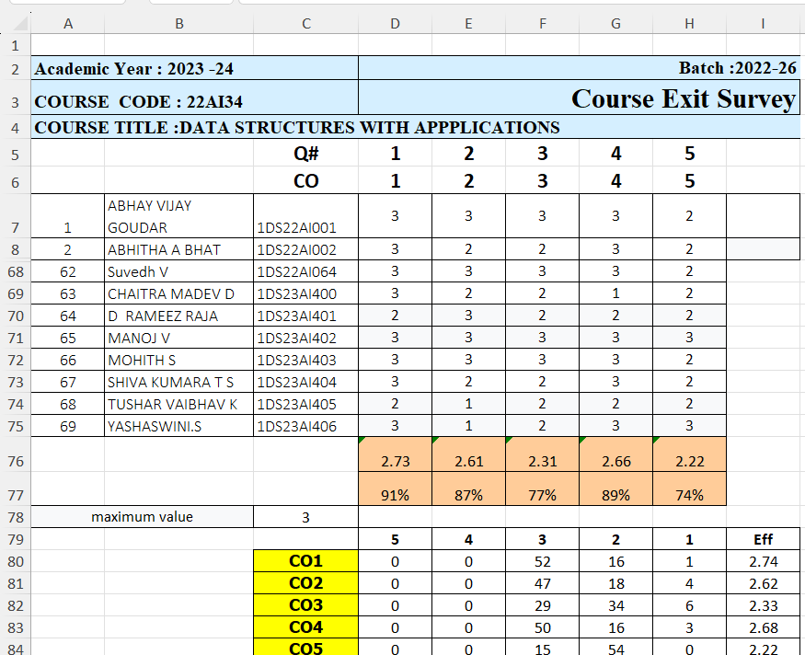
- Fill row 5 with question Number
- Fill row 6 with CO Number
- Fill response points from column D7 as per response from students.
- CO wise calculate the average and % of responses.
- Count Number of responses and compute weighted average as below
Suppose for a particular CO:
- 10 students gave rating 5
- 15 students gave rating 4
- 5 students gave rating 3
- 0 students gave rating 2
- 0 students gave rating 1

Step 1: Weighted Average (1–5 scale):
Computation of Weighted Average Score
=((D76*5) +(E76*4) +(F76*3) +(G76*2) +(H76*1)) / SUM (D76:H76)

$$=\frac{\left(10×5)+(15×4)+(5×3)+(0×2)+(0×1\right)}{10+15+5}$$
$$=\frac{50+60+15}{30}=\frac{125}{30}$$
$$=4.17$$
Step 2: Convert to 1–3 scale
Since NBA commonly uses a 3-point scale for attainment, the calculated score (1–5 scale) is converted to 1–3 scale using normalization:
= (((Weighted Score - 1) / 4) * 2) + 1
- Shift the scale to start from 0
- Subtract 1 → (Weighted Score - 1)
- Now range becomes: 0 to 4
- Convert to 0–1 scale (normalization)
- Divide by 4 → (Weighted Score - 1) / 4
- Now range becomes: 0 to 1
- This step ensures proportional representation
- Scale to new range (0–2)
- Multiply by 2 → × 2
- Now range becomes: 0 to 2
- Shift to final range (1–3)
- Add 1 → + 1
- Final range becomes: 1 to 3
$$\text{Score}=\frac{\left(4.17 − 1\right)}{4}×2+1=2.58$$
STEP 4: CO_PO_PSO_MAPPING SHEET
- Enter CO statements in column A rom A4
- Enter CO POPSO Mapping with Mapping Strength between C4 to P8 CO wise.
- Calculate in row 14, sum of each PO strength mapped to all COs

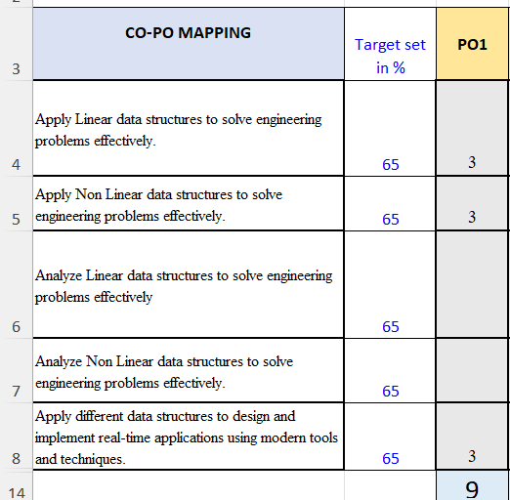
- Calculate Average of all POs mapped to each CO
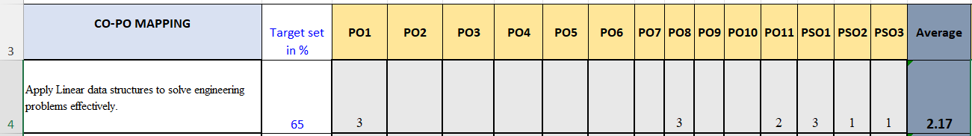

- Enter CIE Question paper details like below 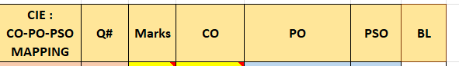

- Enter SEE Question paper details like below
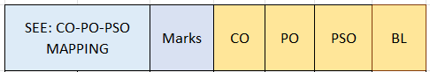

STEP 5 : CO_PO_ASSESSMENT SHEET:
Steps for Final CO–PO–PSO Attainment Calculation in 2 main steps
Step 1: To Compute Final CO Attainment
1.1 Extract Theory CIA CO Attainment
Compute CO attainment based on CIA (CIA-1, CIA-2, CIA-3), AAT, quiz, and internal assessments
IF(COUNTIFS(INDIRECT("'Theory'!"&$G$2&":"&$I$2),"=*1*",
INDIRECT("'Theory'!"&$G$4&":"&$I$4),"<>0")=0,"",
SUMIF(INDIRECT("'Theory'!"&$G$2&":"&$I$2),"=*1*",
INDIRECT("'Theory'! "&$G$4&":"&$I$4)) /
COUNTIFS(INDIRECT("'Theory'!"&$G$2&":"&$I$2),"=*1*",
INDIRECT("'Theory'! "&$G$4&":"&$I$4),"<>0"))

Theory CIA CO Attainment
CIA Question# | Q1A | Q1B | Q1A | Q1A | Q1A | Q1B | AAT | QUIZ
COs mapped | 0,1 | 0,1 | 0,1 | 0,1 | 0,1 | 0,1 | 0,1,2,3,4,5 | 0,1,2,3,4,5
CO Attainment | 44.69 | 56.45 | 32.42 | 93.75 | 93.38 | 74.19 | 87.43 | 98.14
CO 1 Attainment | 72.56

CIA Question# | Q2A | Q2B | Q2A | Q2A | Q2A | Q2B | Q1-20 | Q1-20
COs mapped | 0,2 | 0,2 | 0,2 | 0,2 | 0,2 | 0,2 | 0,1,2,3,4,5 | 0,1,2,3,4,5
CO Attainment | 55.24 | 30.79 | 22.04 | 65.00 | 71.31 | 52.38 | 87.43 | 98.14
CO 2 Attainment | 60.29

CIA Question# | Q3A | Q3B | Q4A | Q4B | Q5A | Q6A | Q3A | Q4A | Q5A | Q6A | Q7A | Q8A | Q1-20 | Q1-20
COs mapped | 0,3 | 0,3 | 0,3 | 0,3 | 0,3 | 0,3 | 0,3 | 0,3 | 0,3 | 0,3 | 0,3 | 0,3 | 0,1,2,3,4,5 | 0,1,2,3,4,5
CO Attainment | 23.04 | 53.78 | 46.00 | 60.00 | 45.16 | 41.05 | 59.77 | 37.93 | 60.81 | 54.17 | 54.39 | 27.50 | 87.43 | 98.14
CO3 Attainment | 53.51

CIA Question# | Q3A | Q4A | Q5A | Q6A | Q1-20 | Q1-20
COs mapped | 0,4 | 0,4 | 0,4 | 0,4 | 0,1,2,3,4,5 | 0,1,2,3,4,5
CO Attainment | 51.4286 | 24 | 67.5 | 52.5 | 87.43 | 98.14
CO 4 Attainment | 63.50

CIA Question# | Q7A | Q8A | Q7A | Q8A | Q1-20 | Q1-20
COs mapped | 0,5 | 0,5 | 0,5 | 0,5 | 0,1,2,3,4,5 | 0,1,2,3,4,5
CO Attainment | 45.1852 | 62.5 | 27.0833 | 53.75 | 87.43 | 98.14
CO5 Attainment | 62.35

1.2 Extract Laboratory CIE Attainment
- Calculate CO attainment using lab test and continuous evaluation marks mapped to respective COs.
CO Attainment of LAB  Total Percentage  (Average) | CO1 | CO2 | CO3 | CO4 | CO5
CO Attainment | 0 | 0 | 0 | 0 | 79.08

1.3 Compute Total CIE Attainment
- Combine theory and laboratory CIE attainment to obtain overall CIE CO attainment.
CIE CO Attainment =
IFERROR(SUM(C8,Lab!D$89,Quiz1!D$80,Quiz2!D$80)/SUM(COUNTIFS(C8,"<>"&"",C8,">0"),COUNTIFS(Lab!D$89,"<>"&"",Lab!D$89,">0"),COUNTIFS(Quiz1!D$80,"<>"&"",Quiz1!D$80,">0"),COUNTIFS(Quiz2!D$80,"<>"&"",Quiz2!D$80,">0")),"")

CO Attainment | Theory | Lab | CIE ( Average of Theory and Lab)
CO 1 | 72.56 |  | 72.56
CO 2 | 60.29 |  | 60.29
CO 3 | 53.51 |  | 53.51
CO 4 | 63.50 |  | 63.50
CO 5 | 62.35 | 79.08 | 70.71

1.4 Compute SEE CO Attainment
- Calculate CO attainment based on Semester End Examination (SEE) performance.

1.5 Extract CES Attainment (Indirect Assessment)
- Determine CO attainment from Course Exit Survey (student feedback).

1.6 Calculate Final CO Attainment
- Apply weightages as per NBA guidelines:
  - 60% weightage to CIE
  - 40% weightage to SEE
  - Combine as Direct Attainment = (0.6 × CIE + 0.4 × SEE)
  - Assign 90% weightage to Direct Attainment
  - Assign 10% weightage to CES
  - Final CO Attainment = (0.9 × Direct Attainment) + (0.1 × CES)

Final CO Attainment
CIE | SEE | CES | CO Attainment =  90%(CIE-60% + SEE-40%) + 10%(CES)
72.56 | 56.99 | 91.00 | 68.80
60.29 | 56.99 | 87.00 | 61.77
53.51 | 56.99 | 78.00 | 57.21
63.50 | 56.99 | 89.00 | 63.71
70.71 | 56.99 | 74.00 | 66.10

Step 2 : Compute Final PO Attainment

The final CO–PO–PSO mapping is computed using a systematic and data-driven approach that ensures objectivity and compliance with NBA guidelines. Initially, the mapping strength between Course Outcomes (CO) and Program Outcomes (PO)/Program Specific Outcomes (PSO) is verified. Only those mappings with a strength greater than or equal to 1 are considered valid for further evaluation. Once the existence of mapping is confirmed, the level of mapping is determined based on the percentage of marks distribution associated with the respective CO. If the contribution of marks lies between 0 and 10 percent, the mapping is classified as Level 1 (Low). For contributions between 10 and 20 percent, it is categorized as Level 2 (Medium), and for contributions exceeding 20 percent, it is assigned Level 3 (High). This methodology ensures that the final mapping reflects not only the existence of alignment between COs and POs/PSOs but also the extent of their contribution based on assessment weightage, thereby enabling a more accurate and measurable attainment analysis.

Final CO PO PSO Mapping table will be generated based on the formula which converts raw mapping into standardized mapping:

- Raw mapping + marks weightage → standardized 3-level mapping

The final CO–PO–PSO mapping table is generated by:
✔ Validating whether a CO contributes to a PO/PSO
✔ Quantifying the contribution using assessment weight (%)
✔ Converting it into standardized levels (1–Low, 2–Medium, 3–High)

Automating the final CO–PO–PSO mapping level (1, 2, or 3) based on two important criteria.
- Instead of subjective assignment, this method uses:
  - Assessment weightage (objective data)
  - Mapping existence (validity check)

- Given mapping strength - Mapping existence (validity check)

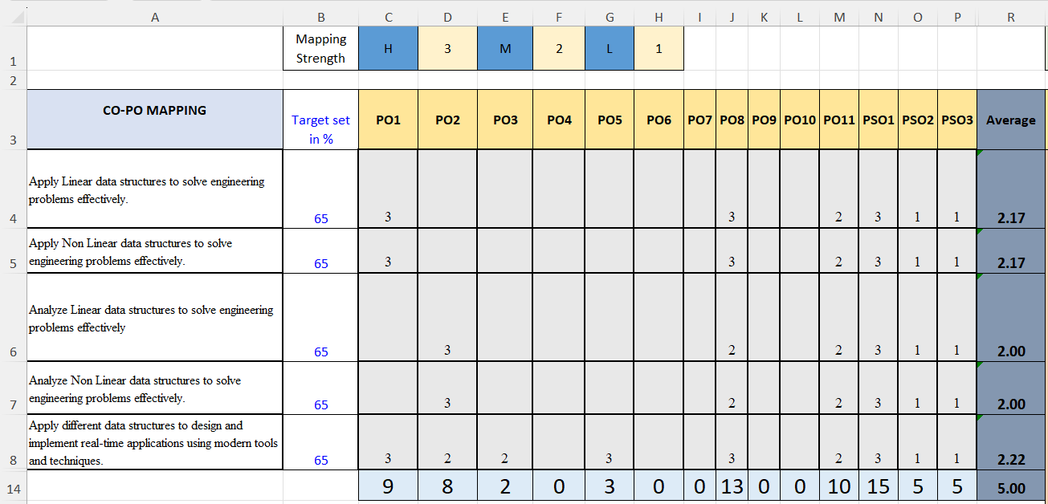
- Percentage of Marks distribution - Assessment weightage (objective data)
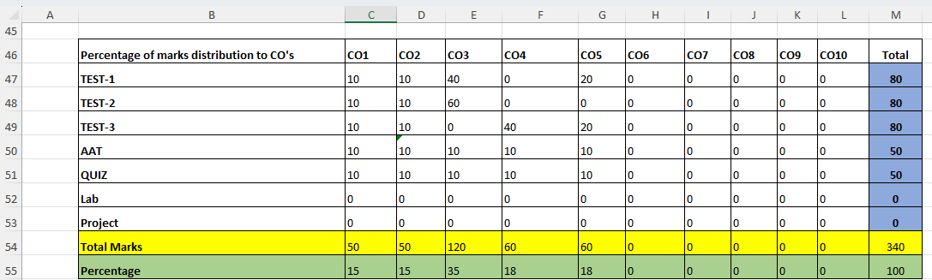
Example:
1. Conditions Used in the Formula
IF (CO_PO_PSO_MAPPING! C4>=1,
IF (AND ($C$55<=10, $C$55>0),1,
IF(AND($C$55>10, $C$55<=20),2,
IF($C$55>20,3,"")
)
),
"")

(a) Mapping Strength Check

CO_PO_PSO_MAPPING! C4 >= 1
- This ensures that a CO is actually mapped to a PO/PSO
- If mapping is:
- 0 or “ “ → No mapping → Output = " " (blank)
- ≥1 → Valid mapping → proceed to next condition
So, no mapping → no attainment level assigned

(b) Percentage of Marks Distribution
C55: This represents how much weight (%) of assessment contributes to that CO.

2. Logic of Mapping Level Calculation
Once mapping exists, the formula assigns levels based on percentage contribution (C55):

Marks % (C55) | Final Mapping Level
0 < C55 ≤ 10 | 1 (Low)
10 < C55 ≤ 20 | 2 (Medium)
C55 > 20 | 3 (High)

Step-by-Step Working
Let’s break your first formula:
IF (CO_PO_PSO_MAPPING! C4>=1,
IF (AND ($C$55<=10, $C$55>0),1,
IF(AND($C$55>10, $C$55<=20),2,
IF($C$55>20,3,"")
)
),
"")
Step 1: Check mapping exists | Step 2: Check percentage (C55)
- If C4 < 1 → result = blank  - If C4 ≥ 1 → go to next step | - If 0 < C55 ≤ 10 → assign Level 1  - If 10 < C55 ≤ 20 → assign Level 2  - If C55 > 20 → assign Level 3
Simple Example
Parameter | Place Holder | Case 1: | Case 2: | Case 3: | Case 4:
Input Mapping strength | C4 | 2 | 1 | 3 | 0 ❌
Marks % | C55 | 8% | 15% | 25%
Output Mapping  Strength | C59 TO P63 | 1(Low mapping) | 2(Medium mapping) | 3(High mapping) | Blank  (No mapping)

Auto Generated standardized 3-level mapping
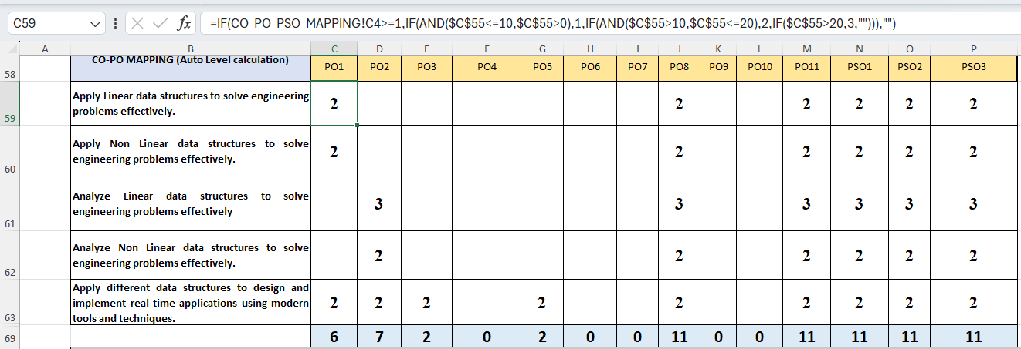
Once we get the final version of CO PO PSO mapping strengths,PO PSO Attainment will be calculated using the formula
( CO Attainment *PO Mapping Strength ) / (Sum total of PO for all COs)
PO1 Attainment = (CO1 Attainment * PO1 mapping for CO1/ Sum of PO1 for all COs) +
(CO2 Attainment * PO1 mapping for CO1/ Sum of PO1 for all COs) +
(CO3 Attainment * PO1 mapping for CO1/ Sum of PO1 for all COs) +
(CO4 Attainment * PO1 mapping for CO1/ Sum of PO1 for all COs) +
(CO5 Attainment * PO1 mapping for CO1/ Sum of PO1 for all COs) +

PO1 Attainment = ( 71.29 * 2 / 6 ) + ( 62.3 *2 / 6 ) + ( 56.66 * 0 ) + ( 64.75 * 0) + ( 68.30 * 2 / 6)
=67.30
PO2 Attainment = ( 71.29 * 0 ) + ( 62.3 *0 ) + ( 56.66 * 3 / 7 ) + ( 64.75 * 2 / 7) + ( 68.3 * 2 / 7)
=62.30
PO3 Attainment = ( 71.29 * 0 ) + ( 62.3 *0 ) + ( 56.66 * 0 ) + ( 64.75 * 0) + ( 68.3 * 2 / 2)
= 68.30
. . .
PO8 Attainment = ( 71.29 * 2 / 11 ) + ( 62.3 *2 / 11 ) + ( 56.66 * 3 / 11 ) + ( 64.75 * 2 / 11) + ( 68.3 * 2 / 11)

= 63.93
. . .
PSO3 Attainment = ( 71.29 * 2 / 11 ) + ( 62.3 *2 / 11 ) + ( 56.66 * 3 / 11 ) + ( 64.75 * 2 / 11) + ( 68.3 * 2 / 11)
= 63.93
Final CO Po PSO Attainment Table
 | 1 | 2 | 3 | 4 | 5 | 6 | 7 | 8 | 9 | 10 | 11 | 1 | 2 | 3
CO ATTAINMENT | 68.8 | 61.8 | 57.21 | 63.7 | 66.1
PO ATTAINMENT  (in %) | 67.30 | 62.30 | 68.30 |  | 66.10 |  |  | 63.93 |  |  | 62.9 | 62.94 | 62.9 | 63.93
PO ATTAINMENT  (in 1-3 Range) | 1.97 | 1.85 | 1.98 |  | 1.98 |  |  | 1.89 |  |  | 1.89 | 1.89 | 1.89 | 1.89

